11. Python Program to Solve the 8-Queen Problem
Aim
To write a Python program to place eight queens on an 8 × 8 chessboard so that no two queens attack each other.
Algorithm
- Start the program.
- Place one queen in each row.
- Check whether the queen conflicts with any previously placed queen.
- If there is no conflict, place the queen and move to the next row.
- If a conflict occurs, try another column.
- Continue until all eight queens are placed.
- Display the chessboard and stop.
Python Program:
N = 8
board = [-1] * N
def safe(row, col):
for i in range(row):
if board[i] == col:
return False
if abs(board[i] - col) == abs(i - row):
return False
return True
def solve(row):
if row == N:
return True
for col in range(N):
if safe(row, col):
board[row] = col

if solve(row + 1):
return True
board[row] = -1
return False
if solve(0):
print("Solution:")
for row in range(N):
for col in range(N):
if board[row] == col:
print("Q", end=" ")
else:
print(".", end=" ")
print()
else:
print("No solution found")
Output:
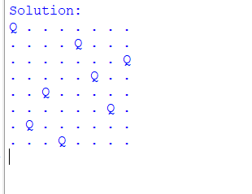
12. Python Program for the Water Jug Problem
Aim
To write a Python program to solve the Water Jug Problem using the Breadth-First Search (BFS) algorithm.
Algorithm
- Start the program.
- Define the capacities of two water jugs and the target amount.
- Start with both jugs empty.
- Generate possible states by filling, emptying, or transferring water between jugs.
- Use BFS to find a sequence of states that reaches the target.
- Display the solution steps.
- Stop the program.
Python Program
from collections import deque
def water_jug(cap1, cap2, target):
start = (0, 0)
queue = deque([(start, [start])])
visited = {start}
while queue:
(a, b), path = queue.popleft()
if a == target or b == target:
return path
states = [
(cap1, b), # Fill jug 1
(a, cap2), # Fill jug 2
(0, b), # Empty jug 1
(a, 0), # Empty jug 2
(a - min(a, cap2 - b),
b + min(a, cap2 - b)), # Pour 1 into 2
(a + min(b, cap1 - a),
b - min(b, cap1 - a)) # Pour 2 into 1
]
for state in states:
if state not in visited:
visited.add(state)
queue.append((state, path + [state]))
return None
cap1 = 4
cap2 = 3
target = 2
solution = water_jug(cap1, cap2, target)
if solution:
print("Water Jug Solution:")
for state in solution:
print(state)
else:
print("Target cannot be reached")
Output:
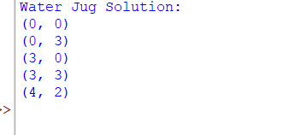
13. Python Program for the Crypt-Arithmetic Problem
Aim
To write a Python program to solve a crypt-arithmetic problem in which each letter represents a unique digit.
Algorithm
- Start the program.
- Consider the equation SEND + MORE = MONEY.
- Assign different digits to each letter.
- Ensure that the first letters of the numbers are not zero.
- Check whether the equation is correct.
- Display the valid solution.
- Stop the program.
Python Program
from itertools import permutations
letters = "SENDMORY"
digits = "0123456789"
for p in permutations(digits, 8):
d = dict(zip(letters, p))
if d['S'] == '0' or d['M'] == '0':
continue
send = int(d['S'] + d['E'] + d['N'] + d['D'])
more = int(d['M'] + d['O'] + d['R'] + d['E'])
money = int(d['M'] + d['O'] + d['N'] + d['E'] + d['Y'])
if send + more == money:
print("SEND =", send)
print("MORE =", more)
print("MONEY =", money)
break
output:
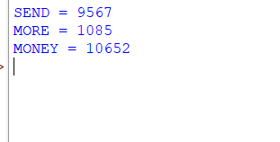

14. Python Program for the Missionaries and Cannibals Problem
Aim
To write a Python program to solve the Missionaries and Cannibals problem using Breadth-First Search (BFS).
Algorithm
- Start the program.
- Consider three missionaries and three cannibals on the left bank.
- Allow the boat to carry one or two people at a time.
- Ensure that cannibals never outnumber missionaries on either bank when missionaries are present.
- Use BFS to find a safe sequence of crossings.
- Display the solution steps.
- Stop the program.
Python Program
from collections import deque
def solve():
start = (3, 3, 0)
goal = (0, 0, 1)
queue = deque([(start, [start])])
visited = {start}
moves = [
(1, 0), (2, 0), (0, 1),
(0, 2), (1, 1)
]
while queue:
state, path = queue.popleft()
m, c, boat = state
if state == goal:
return path
for dm, dc in moves:
if boat == 0:
nm, nc, nb = m - dm, c - dc, 1
else:
nm, nc, nb = m + dm, c + dc, 0
if not (0 <= nm <= 3 and 0 <= nc <= 3):
continue
ml, cl = nm, nc
mr, cr = 3 - nm, 3 - nc
if ml > 0 and cl > ml:
continue
if mr > 0 and cr > mr:
continue
new_state = (nm, nc, nb)
if new_state not in visited:
visited.add(new_state)
queue.append((new_state, path + [new_state]))
return None
solution = solve()
if solution:
print("Missionaries and Cannibals Solution:")
for state in solution:
print(state)
else:
print("No solution found")
output:

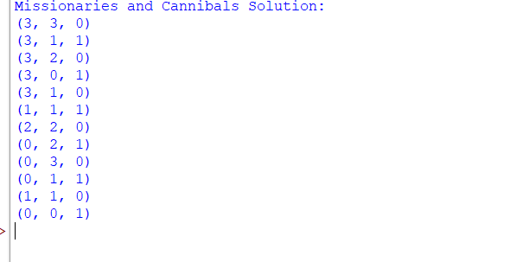

15. Python Program for the Vacuum Cleaner Problem
Aim
To write a Python program to implement a simple vacuum cleaner agent that cleans dirty rooms.
Algorithm
- Start the program.
- Define two rooms, A and B.
- Represent each room as dirty or clean.
- Check the condition of each room.
- If a room is dirty, clean it.
- Display the status of both rooms.
- Stop the program.
Python Program
rooms = {
'A': 'Dirty',
'B': 'Dirty'
}
location = 'A'
while True:
print("Vacuum cleaner is in room", location)
if rooms[location] == 'Dirty':
print("Cleaning room", location)
rooms[location] = 'Clean'
else:
print("Room", location, "is already clean")
if location == 'A':
location = 'B'
else:
location = 'A'
if all(status == 'Clean' for status in rooms.values()):
break
print("All rooms are clean")
print("Final room status:", rooms)
Output:
